1. explain about docker architecture?
Docker architecture mainly consists of three core components: Docker Client, Docker Host, and Docker Registry.
The Docker Client is the interface through which users interact with Docker using commands. It sends requests to the Docker Daemon.
The Docker Host runs the Docker Daemon, which is responsible for building images, running containers, and managing resources. It contains images and containers.
The Docker Registry is a storage system where Docker images are stored and shared. By default, Docker pulls images from Docker Hub.
So, the workflow is: the client sends commands to the daemon, the daemon processes them, pulls images from the registry if needed, and creates containers.
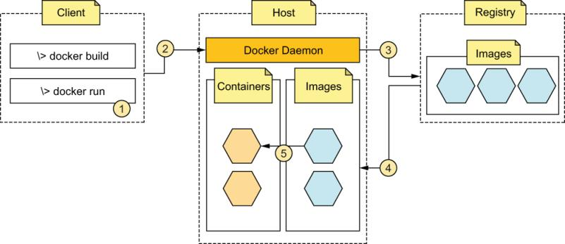

2. refer all docker commands?
Docker commands are mainly categorized into image management, container management, monitoring, and networking. For example, we use docker pull to download images, docker run to create containers, docker ps to list containers, and docker logs to monitor them.

📦 Image Commands
docker pull nginx # Download image
docker images # List images
docker rmi <image_id> # Remove image
docker build -t myapp . # Build image from Dockerfile

📦 Container Commands
docker run -d nginx # Run container
docker run -it ubuntu /bin/bash # Interactive container
docker ps # Running containers
docker ps -a # All containers
docker stop <id> # Stop container
docker start <id> # Start container
docker rm <id> # Remove container

🔍 Monitoring & Logs
docker logs <container_id> # View logs
docker logs -f <container_id> # Live logs
docker top <container_id> # Processes
docker stats # Resource usage

🧱 Inspect & Debug
docker inspect <id> # Detailed info
docker exec -it <id> bash # Access container

🌐 Networking
docker network ls
docker network create mynet

💾 Volumes
docker volume ls
docker volume create myvol

🧹 Cleanup
docker system prune

DOCKER COMMANDS:
DOCKER COMMANDS
1. To see the list of images : docker images
2. To pull the image : docker pull image-name
3. To create a container : docker run -d --name cont-name -p host-port:container-port
image
4. To see running containers : docker ps
5. To see all containers : docker ps -a
6. To stop the container : docker stop cont-name
7. To stop multiple containers : docker stop cont-1 cont-2 cont-3
8. To stop all containers : docker stop $(docker ps)
9. To start a container : docker start cont-name
10. To start multiple containers : docker start cont-1 cont-2 cont-3
11. To start all containers : docker start $(docker ps -a)
12. To remove a stopped container : docker rm cont-name
13. To remove a running container : docker rm -f cont-name
14. To remove all stopped containers : docker rm $(docker ps -a)
15. To remove an image : docker rmi image-name
16. To remove unused images : docker rmi $(docker images)
17. To get the full info about container : docker inspect cont-name
18. To get the container logs : docker logs cont-name
19. To enter into the container : docker exec -it cont-name bash
20. To get full info about image : docker inspect image image-name

